Document Image Classification Using Deep Learning

Problem Statement
The goal is to build a deep learning model that classifies a full document image into one of sixteen predefined categories: letter, form, email, handwritten, advertisement, scientific report, scientific publication, specification, file folder, news article, budget, invoice, presentation, questionnaire, resume, and memo. The input is a single page image while the output is a class label and confidence score. The complexity in the problem comes from that we can not make the model “read” everytihg in the input and then infer which class of document it is. That will take extremely high computational and decision making times along with a lot of resources. Also I noticed that a lot of classes of document hold a very similar layout may it be letter heads or the way they are modelled so there was no sure shot way of telling them apart by jus the layout of text. The logical way to tackle the problem was to make a hybrid structure where the model learns to recognise visual patterns and layout features of documents rather than reading their content. The backbone EfficientNet-B4 extracts these visual features from the entire page as a 1792 dimensional vector through global average pooling. This vector captures structural patterns like text density and column layout without processing any actual text. The classification head then maps this compact representation to one of sixteen document classes. This approach is fast at inference time and requires no OCR or text extraction pipeline making it practical to deploy on standard hardware.

Dataset Selection
Three datasets RVL-CDIP, Tobacco800, and SROIE were considered.

Dataset | Size | Classes | Notes
RVL-CDIP | 400,000 | 16 | Industry benchmark, perfectly balanced.
Tobacco800 | 3,500 | 10 | High quality but too small to train from scratch. Less number of classes 6
SROIE | 973 | 1 | Receipts only, designed for OCR not classification

I selected RVL-CDIP for the high training data size and also better classes. Its large scale, perfect class balance (25,000 images per class), pre-defined splits. Tobacco800 is retained as a supplementary evaluation set. SROIE is excluded entirely. The dataset is open source and is readily available on https://huggingface.co/datasets/aharley/rvl_cdip . I downloaded the dataset directly using the datasets library made by them. It is around 38GB.

Architectures Considered

The consideration for which model to select started with the basics of documents

Model Type | Models | RVL-CDIP acc. | Notes
CNN backbone | EfficientNet, ResNet, ConvNeXt | 92-94% | Used for this model creation
Vision Transformer | ViT-B/16, Swin-B, DeiT | 95-96% (reported) | Currently being created for better accuracy across all the datasets.
Doc-pretrained ViT | DiT-B, DiT-L, BEiT-v2 | 97-98% (reported) | Developed for specifically document or text baseNd tasks but highly complex
Multimodal | LayoutLMv3, Donut, UDOP | - | Extremly complex to implement and require heavy computational and 3D rendering architecture

CNN Backbones
CNNs extract visual features through successive convolutional layers pretrained on ImageNet. EfficientNet-B4 was chosen because its scaling, simultaneously tuning depth, width, and resolutionis able to provide the best accuracy while stil being relatively low on parameters of the CNN family, achieving 92 to 94 percent on RVL-CDIP. The limitation is that convolutional operations are local: the model cannot directly reason about full page layout structure which is the primary discriminating signal between visually similar classes such as letter, memo, and email. This makes CNNs a strong baseline but not the accuracy ceiling.

Vision Transformers
Vision Transformers divide the image into 16x16 pixel patches and process them with self attention, allowing every patch to learn from its relation with every other patch. This attention that tranformeres provide is a great method because it is able to learn and differentiate between different structures like layout of memo, email, etc. ViT-B/16 achieves 95 to 96 percent on RVL-CDIP. I did not choose this model as my base architecture due to its accessive cost of computation. Fine-tuning requires 12 to 16 GB VRAM.

Document-Pretrained ViT (DiT)
DiT takes the Vision Transformer architecture and pretrains it on the IIT-CDIP document dataset using masked image modelling. Because pretraining is document specific rather than natural image specific. DiT already encodes layout text line regularity. It also makes use of column alignment, header body footer structure before fine-tuning begins. This closes the gap on the hardest class pairs and pushes accuracy to 97 to 98 percent on RVL-CDIP. DiT-B is the final accuracy target for this project, to be trained on Kaggle or Colab.

Multimodal Models
Models such as LayoutLMv3 and Donut process both the document image and its extracted text simultaneously, reaching 98 to 99 percent on RVL-CDIP. They were excluded for three reasons: the accuracy gain over DiT-B is only 1 to 2 percentage points, which does not justify the added pipeline complexity for a classification only task. It requires 24 to 40 GB VRAM even on cloud hardware and they demand an OCR preprocessing step, dual tokenization pipeline, etc that would need to be rebuilt from scratch if the backend changes. That much complexity is not relevant for the current implementation of task but is the logical next step to gain accuracy.

Proposed Solution

1 Model Architecture
The Document Classifier consists of a pretrained EfficientNet-B4 backbone and a custom classification head. The backbone is loaded with ImageNet weights, its original head is removed, and global average pooling reduces the final feature map to a 1792-dimensional vector. The classification head maps this vector through: LayerNorm, Linear(1792, 512), GELU activation, Dropout(0.4), and a final Linear(512, 16). At testing a confidence threshold of 0.70 is applied any predictions below this are removed for low confidence rather than be assigned silently as they can skew the results. The backbone and head are kept separate so swapping to a ViT or DiT backbone in later stages requires no changes to the head or training code.

2 Training Strategy
Training runs in two phases. Phase 1 (8 epochs) freezes the backbone and trains the head only at learning rate stabilising the head before backbone gradients flow and preventing the randomly initialised head from damaging pretrained weights. Phase 2 (up to 15 epochs) unfreezes all layers at learning rate 1e-4 with mixup augmentation (alpha 0.4) and early stopping at patience 6. Mixed precision training halves VRAM usage, enabling batch size 16 on the 8 GB GPU. A WeightedRandomSampler ensures balanced gradient contribution across all 16 classes. Label smoothing of 0.10 reduces overconfidence at ambiguous class boundaries. Augmentation covers improves the training by giving a better selction of inputs with different colour, rotation, brightness,etc.

Evaluation
All evaluation is performed on the held-out RVL-CDIP test set of 40,000 images from the saved best_model.pt checkpoint. During training the maximum overall accuracy achieved was 90.46%

- Overall accuracy on 40,000 test images
- Per class precision, recall, and F1 identifies which classes the model confuses
- Evaluation scores after training was done. Evaluation and testing was done on a completely separate testing split of the dataset containing 40,000 images that were strictly not used for training so there can be no overfitting.
- Model performance metrics
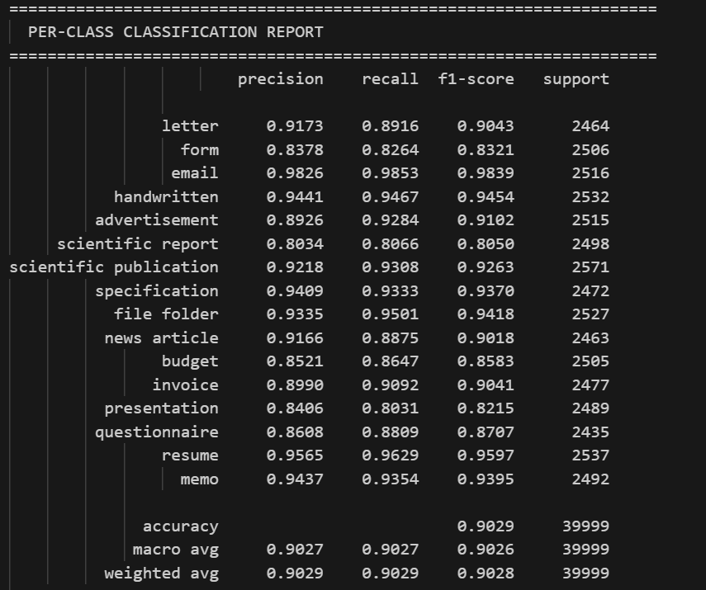

- 16x16 confusion matrix: highlights systematic misclassification at ambiguous class boundaries
- Confidence distribution 